Task 2: Multivariate EDA & Static Dashboard
Python Exploratory & Statistical Analysis — sales_dataset_python_analysis.csv
Data Analytics Internship Deliverable
Prepared by: Brojo Mohan Dutta

Executive Summary
This report presents the multivariate exploratory data analysis performed on the row-level ApexPlanet sales extract (995 transactions after filtering to the 2025 calendar year). The analysis covers correlation structure, pairwise relationships, and segment-level revenue patterns across product category, city, age group, and gender, closing with a static executive dashboard mock-up. Total revenue across the analysed period is ₹138,590,050 across 995 orders, an average order value of ₹139,286. Electronics is the leading category by revenue (₹50.68M), followed by Education (₹25.03M), Grocery (₹21.87M), Furniture (₹21.52M), and Fashion (₹19.49M).

1. Correlation Matrix — Numeric Variables
A Pearson correlation matrix was computed across the four numeric fields to check for multicollinearity and identify the strongest linear drivers of revenue before building the multivariate visuals.
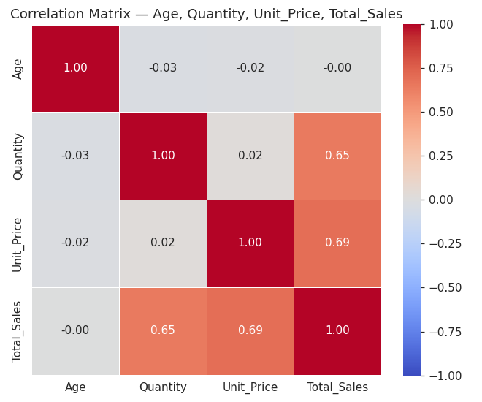
Figure 1. Correlation matrix — Age, Quantity, Unit_Price, Total_Sales.
- Total_Sales correlates most strongly with Unit_Price (r = 0.69) and Quantity (r = 0.65) — expected, since revenue is their product.
- Age shows negligible correlation with all three transactional variables (|r| ≤ 0.03), indicating age does not linearly predict spend, quantity, or price point in this dataset.
- Quantity and Unit_Price are effectively uncorrelated (r = 0.02), so customers are not systematically buying more units at lower prices or vice versa.

2. Pair Plot — Numeric Variables by Category
A Seaborn pair plot visualizes all pairwise numeric relationships simultaneously, with KDE diagonals and points coloured by product Category, to check for category-specific clustering that a single correlation coefficient would hide.
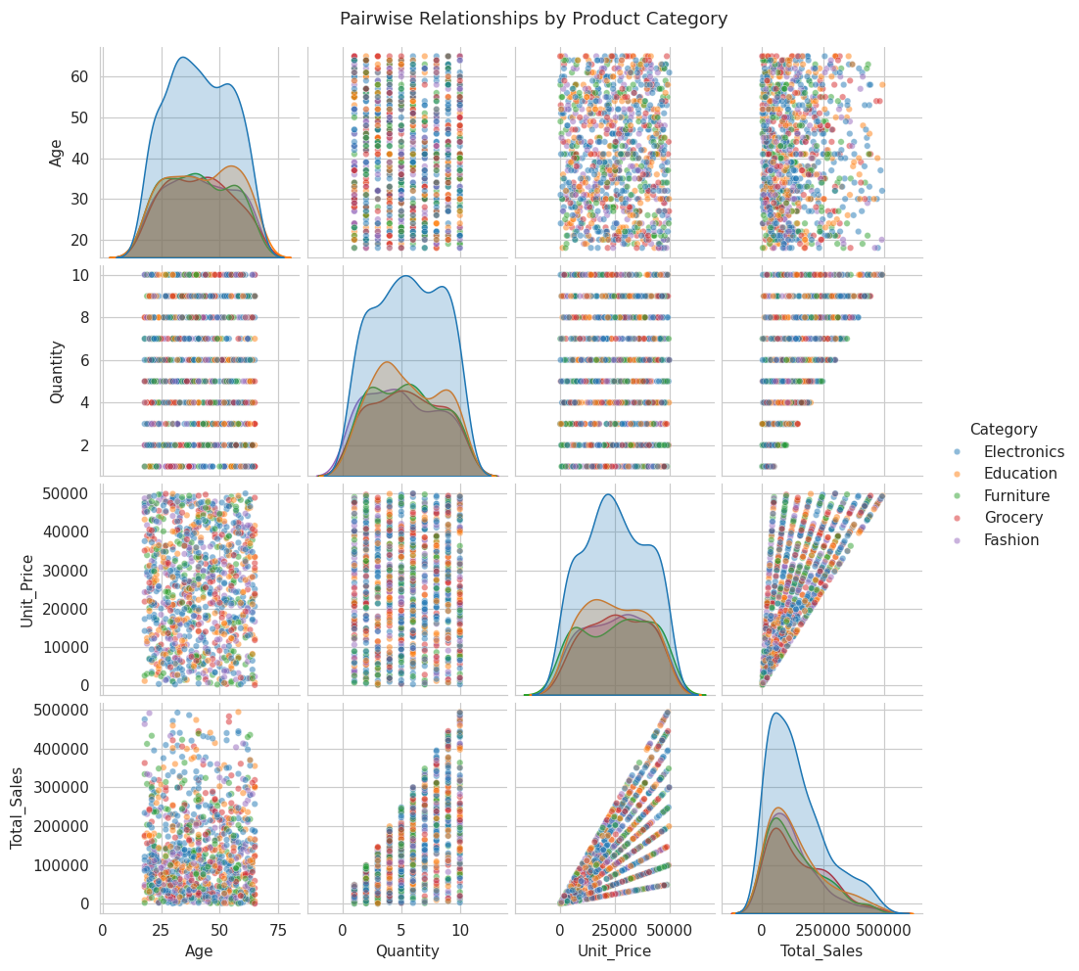
Figure 2. Pairwise relationships (Age, Quantity, Unit_Price, Total_Sales), coloured by Category.
The diagonal KDEs show Electronics and Furniture skew toward higher Unit_Price and Total_Sales, while Grocery and Education cluster at the lower end — consistent with the category revenue ranking above. No category forms a visually distinct age cluster.

3. Scatter Plot — Age vs. Total Sales by Category
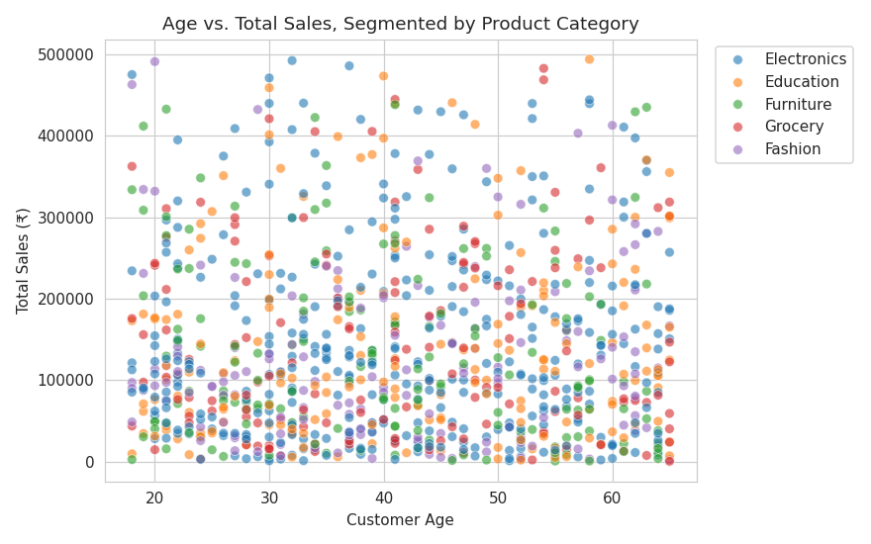
Figure 3. Age vs. Total Sales, segmented by Category.
Points are broadly scattered across the full 18–65 age range for every category with no visible trend line, reinforcing the near-zero correlation from Section 1 — age is not a useful standalone predictor of order value in this dataset.

4. Scatter Plot — Quantity vs. Unit Price by Gender
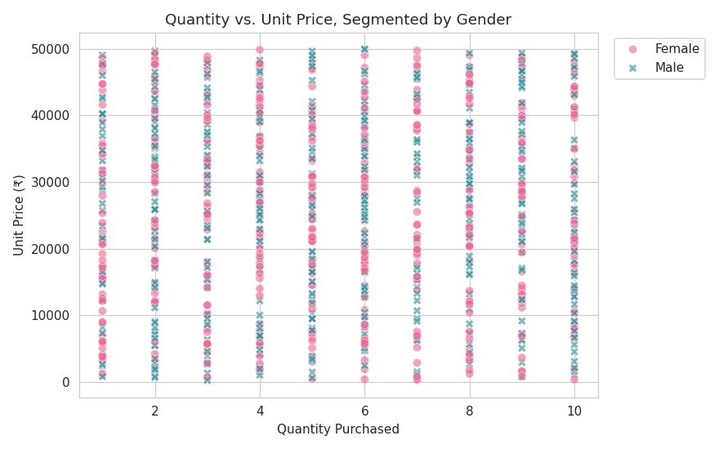
Figure 4. Quantity vs. Unit Price, segmented by Gender.
Male and female customers show overlapping, evenly distributed purchase patterns across quantity and price — gender does not visibly separate the two variables.

5. Heatmap — Average Order Value by City × Category
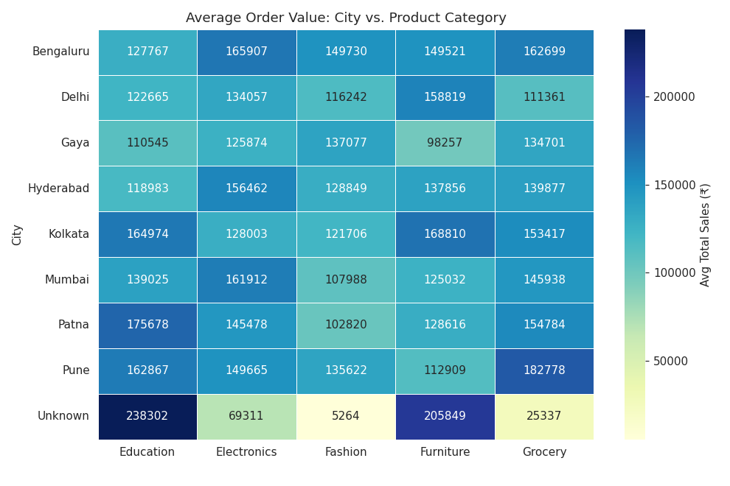
Figure 5. Average Total_Sales: City vs. Category.
Average order value varies more by category than by city — Electronics and Furniture command the highest per-order averages in nearly every city, while Grocery is consistently the lowest, suggesting category (product mix) rather than geography is the primary lever for order-value optimisation.

6. Heatmap — Average Order Value by Age Group × Category
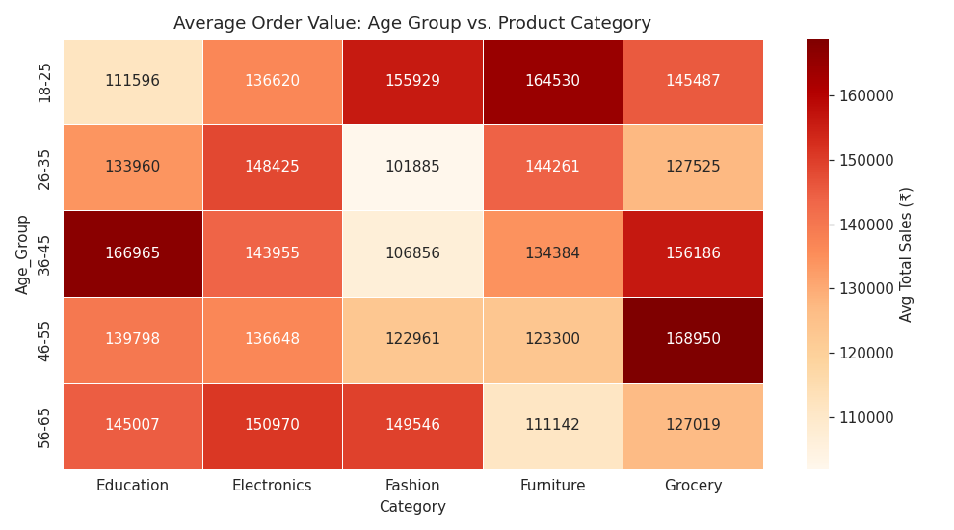
Figure 6. Average Total_Sales: Age Group vs. Category.
No single age band dominates any category's average order value — values are fairly evenly spread across the five age groups within each category, which is consistent with the flat Age correlation observed earlier.

7. Box Plot — Total Sales Distribution by Category and Gender
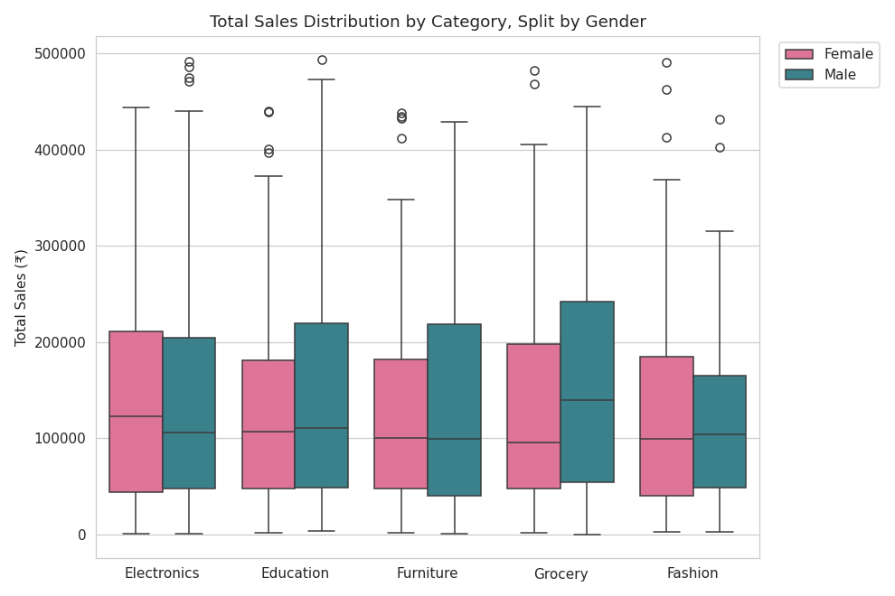
Figure 7. Total Sales distribution by Category, split by Gender.
Electronics and Furniture show the widest spread and highest medians, reflecting their higher unit prices, while Grocery and Education are tightly clustered near the bottom of the range. Within each category, male and female distributions overlap closely, with no consistent gender gap in order value.

8. Static Dashboard Mock-Up
A single-page executive dashboard was composed from four KPI cards, a monthly revenue trend line, category and city revenue bar charts, an age-group bar chart, a gender revenue-share donut, and a Category × City revenue heatmap — combining the granular EDA above into one stakeholder-ready view.
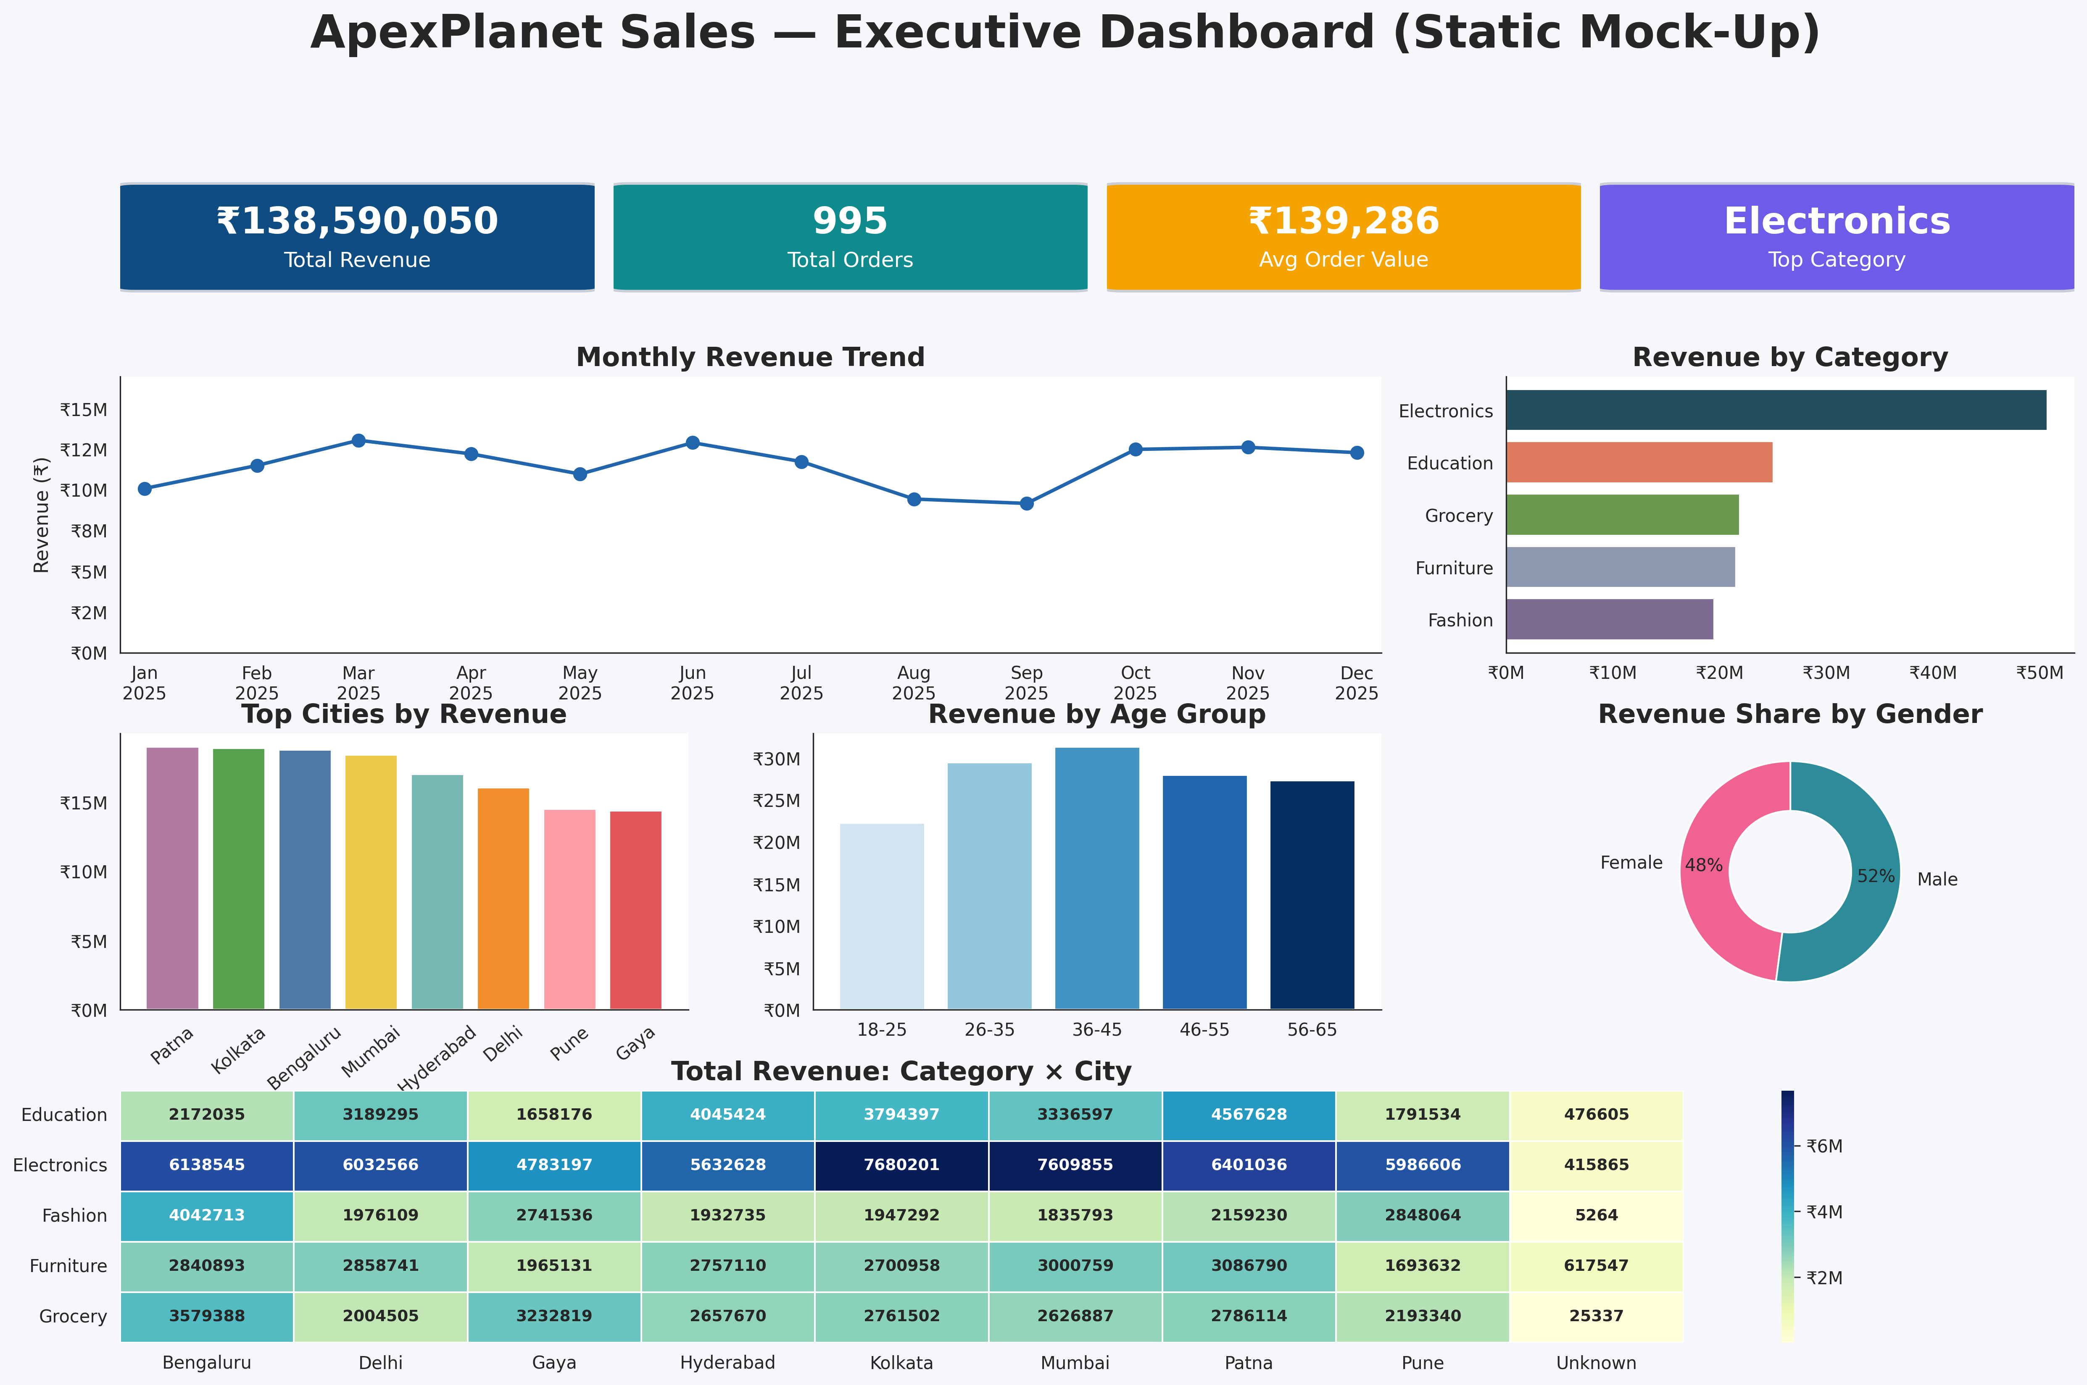
Figure 8. ApexPlanet Sales — Executive Dashboard (static mock-up).
- Total Revenue ₹138,590,050 across 995 orders; Average Order Value ₹139,286.
- Electronics is confirmed as the top category on the dashboard's revenue bar chart, consistent with Section 1's findings.
- Revenue is fairly evenly split by gender (52% male / 48% female) and by age group, with no single segment dominating — reinforcing that category mix, not demographics, is the main revenue driver.
- Monthly revenue is relatively stable through the year with a peak in March and June and a dip in August/September, useful as a starting point for seasonality investigation in a follow-up analysis.

Appendix — Corrected Python Script
The full corrected script (sections 1–8 combined) is below and provided separately as ApexPlanet_Task2_Python_EDA.py.
"""
ApexPlanet Software Pvt. Ltd. — Data Analytics Internship
Task 2: Multivariate EDA & Static Dashboard Mock-Up (Customized Version)

Dataset: sales_dataset_python_analysis.csv
Author: Brojo Mohan Dutta
Environment: Jupyter Notebook / Python 3.x / Pandas, NumPy, Matplotlib, Seaborn, SciPy
"""
# ApexPlanet Software Pvt. Ltd. — Data Analytics Internship Task 2: Multivariate EDA & Static Dashboard Mock-Up **Dataset:** `sales_dataset_python_analysis.csv`\ **Prepared by:** Brojo Mohan Dutta\ **Environment:** Jupyter Notebook / Python 3.x / Pandas, NumPy, Matplotlib, Seaborn
# 1. Setup & Data Load
#── Import Required Libraries ────────────────────────────────────────────────────────────
# Data Manipulation
import pandas as pd
import numpy as np

# Data Visualization
import matplotlib.pyplot as plt
import matplotlib.gridspec as gridspec
import matplotlib.ticker as mticker
import seaborn as sns
from matplotlib.patches import FancyBboxPatch

# Statistics
from scipy import stats

sns.set_style("whitegrid")
plt.rcParams["figure.dpi"] = 110

DATA_PATH = "sales_dataset_python_analysis.csv"
df = pd.read_csv(DATA_PATH)

df["Order_Date"] = pd.to_datetime(df["Order_Date"], format="%Y-%m-%d")

df = df[df["Order_Date"] < "2026-01-01"]

numeric_cols = ["Age", "Quantity", "Unit_Price", "Total_Sales"]
categorical_cols = ["Gender", "City", "Category", "Age_Group"]

# ── Global colour palette ────────────────────────────────────────────────────────────
category_colors = {"Electronics": "#234F5C","Education": "#E07A5F","Grocery": "#6A994E","Furniture": "#8D99AE","Fashion": "#7D6B91"}

city_colors = ["#B07AA1","#59A14F","#4E79A7","#EDC948","#76B7B2","#F28E2B","#FF9DA7","#E15759"]

age_colors = ["#D1E5F0","#92C5DE","#4393C3","#2166AC","#053061"]

gender_colors = ["#F06292","#2E8B99"]

print(df.shape)
df.info()
# 2. Correlation Matrix — Numeric Variables
corr_matrix = df[numeric_cols].corr()

plt.figure(figsize=(6, 5))
sns.heatmap(corr_matrix, annot=True, fmt=".2f", cmap="coolwarm",
vmin=-1, vmax=1, square=True, linewidths=0.5)
plt.title("Correlation Matrix — Age, Quantity, Unit_Price, Total_Sales")
plt.tight_layout()
plt.savefig("01_chart_correlation_heatmap.png")
plt.show()
# 3. Pair Plot — Numeric Variables by Category
pair_grid = sns.pairplot(
df[numeric_cols + ["Category"]],
hue="Category",
diag_kind="kde",
plot_kws={"alpha": 0.5, "s": 18},
height=2.2,
)
pair_grid.fig.suptitle("Pairwise Relationships by Product Category", y=1.02)
pair_grid.savefig("02_chart_pairplot_category.png")
plt.show()
# 4. Scatter Plot — Age vs. Total_Sales by Category
plt.figure(figsize=(8, 5))
sns.scatterplot(data=df, x="Age", y="Total_Sales", hue="Category",
alpha=0.6, s=40, palette="tab10")
plt.title("Age vs. Total Sales, Segmented by Product Category")
plt.xlabel("Customer Age")
plt.ylabel("Total Sales (₹)")
plt.legend(bbox_to_anchor=(1.02, 1), loc="upper left")
plt.tight_layout()
plt.savefig("03_chart_scatter_age_sales.png")
plt.show()
# 5. Scatter Plot — Quantity vs. Unit_Price by Gender
plt.figure(figsize=(8, 5))
sns.scatterplot(data=df, x="Quantity", y="Unit_Price", hue="Gender",
style="Gender", alpha=0.6, s=45, palette=gender_colors)
plt.title("Quantity vs. Unit Price, Segmented by Gender")
plt.xlabel("Quantity Purchased")
plt.ylabel("Unit Price (₹)")
plt.legend(bbox_to_anchor=(1.02, 1), loc="upper left")
plt.tight_layout()
plt.savefig("04_chart_scatter_qty_price.png")
plt.show()
# 6. Heatmap — Average Total_Sales by City x Category
pivot_city_category = df.pivot_table(
index="City", columns="Category", values="Total_Sales", aggfunc="mean"
).round(0)
plt.figure(figsize=(9, 6))
sns.heatmap(pivot_city_category, annot=True, fmt=".0f", cmap="YlGnBu",
linewidths=0.5, cbar_kws={"label": "Avg Total Sales (₹)"})
plt.title("Average Order Value: City vs. Product Category")
plt.tight_layout()
plt.xlabel("")
plt.savefig("05_chart_heatmap_city_category.png")
plt.show()
# 7. Heatmap — Average Total_Sales by Age_Group x Category
pivot_age_category = df.pivot_table(
index="Age_Group", columns="Category", values="Total_Sales", aggfunc="mean"
).round(0)

age_order = ["18-25", "26-35", "36-45", "46-55", "56-65"]
pivot_age_category = pivot_age_category.reindex(
[g for g in age_order if g in pivot_age_category.index]
)

plt.figure(figsize=(9, 5))
sns.heatmap(pivot_age_category, annot=True, fmt=".0f", cmap="OrRd",
linewidths=0.5, cbar_kws={"label": "Avg Total Sales (₹)"})
plt.title("Average Order Value: Age Group vs. Product Category")
plt.tight_layout()
plt.savefig("06_chart_heatmap_age_category.png")
plt.show()
# 8. Box Plot — Total_Sales Distribution by Category and Gender
plt.figure(figsize=(9, 6))
sns.boxplot(data=df, x="Category", y="Total_Sales", hue="Gender", palette=gender_colors)
plt.title("Total Sales Distribution by Category, Split by Gender")
plt.ylabel("Total Sales (₹)")
plt.xlabel("")
plt.legend(bbox_to_anchor=(1.02, 1), loc="upper left")
plt.xticks(rotation=0)
plt.tight_layout()
plt.savefig("07_chart_boxplot_category_gender.png")
plt.show()
# 9. Static Dashboard Mock-Up
# ── Dashboard Theme ────────────────────────────────────────────────────────────
plt.style.use("default")
sns.set_style("white")

# ── KPIs ────────────────────────────────────────────────────────────
total_revenue = df["Total_Sales"].sum()
total_orders = df["Order_ID"].nunique()
avg_order_value = df["Total_Sales"].mean()
top_category = df.groupby("Category")["Total_Sales"].sum().idxmax()

fig = plt.figure(figsize=(20,12), facecolor="#F5F7FA")
outer = gridspec.GridSpec(4,3,height_ratios=[0.72,1.7,1.7,1.55],hspace=0.35,wspace=0.22)

def style_panel(ax):
ax.set_facecolor("white")
for s in ax.spines.values():
s.set_color("#D9DDE3")
s.set_linewidth(1)
ax.grid(axis="y",alpha=.18)
ax.set_axisbelow(True)

# ── KPI Cards ────────────────────────────────────────────────────────────
kpi_colors = ["#0F4C81","#0F8B8D","#F4A300","#6C5CE7"]
labels = ["Total Revenue","Total Orders","Avg Order Value","Top Category"]
values = [
f"₹{total_revenue:,.0f}",
f"{total_orders:,}",
f"₹{avg_order_value:,.0f}",
top_category
]

kpi_spec = gridspec.GridSpecFromSubplotSpec(1,4,subplot_spec=outer[0,:],wspace=.04)

for i in range(4):
ax = fig.add_subplot(kpi_spec[0,i])
ax.set_xticks([]); ax.set_yticks([])
ax.set_frame_on(False)

card = FancyBboxPatch((0.01,0.06),0.98,0.88,boxstyle="round,pad=0.02,rounding_size=0.04",facecolor=kpi_colors[i],edgecolor="#C9CED6",
linewidth=1.5)
ax.add_patch(card)

ax.text(0.5,0.62,values[i],ha="center",va="center",fontsize=21,fontweight="bold",color="white")
ax.text(0.5,0.30,labels[i],ha="center",va="center",fontsize=12,color="white")

# ── Monthly Trend ────────────────────────────────────────────────────────────
ax1=fig.add_subplot(outer[1,:2])

monthly=(df.groupby(pd.Grouper(key="Order_Date",freq="MS"))["Total_Sales"].sum())

ax1.plot(monthly.index,monthly.values,color="#2166AC",linewidth=2,marker="o",markersize=7)

ax1.set_title("Monthly Revenue Trend",fontsize=15,fontweight="bold")

ax1.set_xlabel("")

ax1.set_ylabel("Revenue (₹)",fontsize=11)

ax1.set_xticks(monthly.index)

ax1.set_xticklabels(monthly.index.strftime("%b\n%Y"),rotation=0)

ax1.grid(False)

ax1.margins(x=0.02)

ax1.set_ylim(0, monthly.max()*1.3)

ax1.spines["top"].set_visible(False)
ax1.spines["right"].set_visible(False)

ax1.yaxis.set_major_formatter(mticker.FuncFormatter(lambda x,pos:f"₹{x/1e6:.0f}M"))

# ── Revenue by Category ────────────────────────────────────────────────────────────
ax2=fig.add_subplot(outer[1,2])

cat=df.groupby("Category")["Total_Sales"].sum().sort_values()

colors=[category_colors[c] for c in cat.index]

ax2.barh(cat.index,cat.values,color=colors)

ax2.set_title("Revenue by Category",fontsize=15,fontweight="bold")

ax2.grid(False)

ax2.spines["top"].set_visible(False)
ax2.spines["right"].set_visible(False)

ax2.xaxis.set_major_formatter(mticker.FuncFormatter(lambda x,pos:f"₹{x/1e6:.0f}M"))

# ── Top Cities ────────────────────────────────────────────────────────────
ax3=fig.add_subplot(outer[2,0])

city=(df.groupby("City")["Total_Sales"].sum().sort_values(ascending=False).head(8))

bars=ax3.bar(city.index,city.values,color=city_colors)

ax3.set_title("Top Cities by Revenue",fontsize=15,fontweight="bold")

ax3.tick_params(axis="x",rotation=40)

ax3.grid(False)

ax3.spines["top"].set_visible(False)
ax3.spines["right"].set_visible(False)

ax3.yaxis.set_major_formatter(mticker.FuncFormatter(lambda x,pos:f"₹{x/1e6:.0f}M"))

# ── Age Group ────────────────────────────────────────────────────────────
ax4=fig.add_subplot(outer[2,1])

age_order=["18-25","26-35","36-45","46-55","56-65"]

age=(df.groupby("Age_Group")["Total_Sales"].sum().reindex(age_order))

ax4.bar(age.index,age.values,color=age_colors)

ax4.set_title("Revenue by Age Group",fontsize=15,fontweight="bold")

ax4.grid(False)

ax4.spines["top"].set_visible(False)
ax4.spines["right"].set_visible(False)

ax4.yaxis.set_major_formatter(mticker.FuncFormatter(lambda x,pos:f"₹{x/1e6:.0f}M"))

# ── Gender Donut ────────────────────────────────────────────────────────────
ax5=fig.add_subplot(outer[2,2])

gender=df.groupby("Gender")["Total_Sales"].sum()

ax5.pie(gender.values,labels=gender.index,autopct="%1.0f%%",startangle=90,radius=1,labeldistance=1.15,pctdistance=0.78,
colors=gender_colors,wedgeprops=dict(width=0.45,edgecolor="white"))

ax5.set_title("Revenue Share by Gender",fontsize=15,fontweight="bold")

# ── Heatmap ────────────────────────────────────────────────────────────
ax6=fig.add_subplot(outer[3,:])

pivot=df.pivot_table(index="Category",columns="City",values="Total_Sales",aggfunc="sum")

hm = sns.heatmap(pivot,cmap="YlGnBu",annot=True,fmt=".0f",linewidths=0.5,annot_kws={"fontsize":9, "fontweight":"bold"},cbar=True,ax=ax6)

cbar = hm.collections[0].colorbar
cbar.formatter = mticker.FuncFormatter(lambda x, pos: f"₹{x/1e6:.0f}M")
cbar.update_ticks()

plt.xlabel("")
plt.ylabel("")
ax6.set_title("Total Revenue: Category × City",fontsize=15,fontweight="bold")

# ── Dashboard Title ────────────────────────────────────────────────────────────
fig.suptitle("ApexPlanet Sales — Executive Dashboard (Static Mock-Up)",fontsize=26,fontweight="bold",y=0.99)

plt.savefig("dashboard_mockup.png",dpi=300,bbox_inches="tight")

plt.show()

Conclusion
The multivariate analysis confirms that Total_Sales is driven primarily by Unit_Price and Quantity, with product Category as the dominant categorical driver of both average order value and total revenue — Age and Gender show minimal explanatory power across every chart in this report. The static dashboard mock-up packages these findings into a single view suitable for stakeholder review ahead of building an interactive BI dashboard in Task 3.

